## ***1. Setup a connection route***

- Go to VirtualBox Network Setup

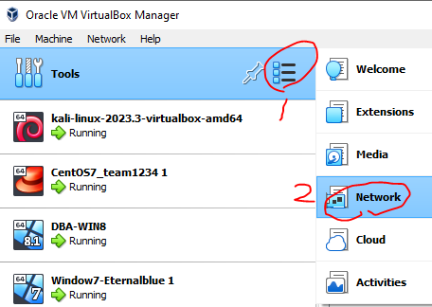

- Go to NAT Networks tab

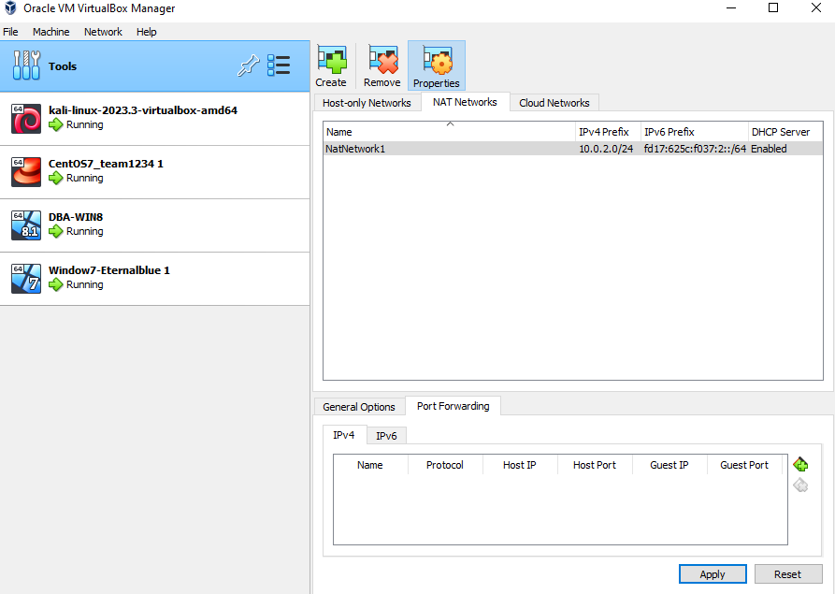

- Go to Port Forwarding tab

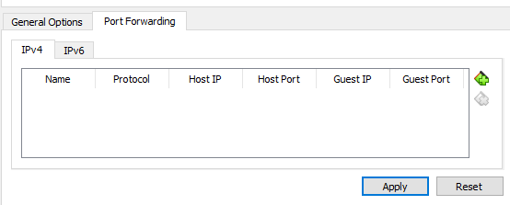

- Add like this

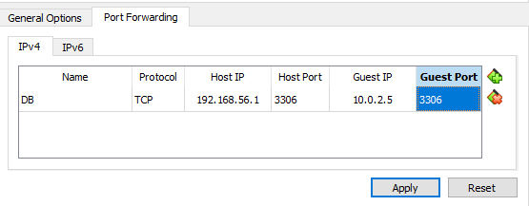

## 

## ***2. Install HeidiSQL in you PC***

- Download HeidiSQL (https://www.heidisql.com/download.php)

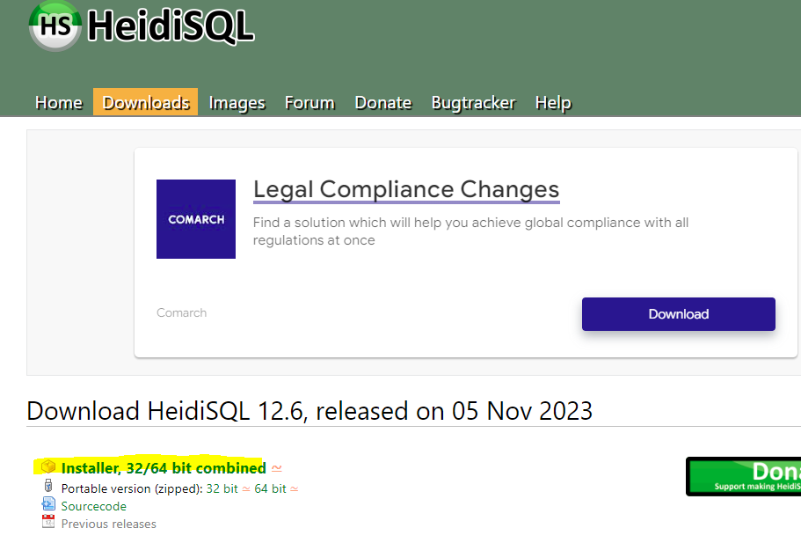

- Install

## ***3. Connect DB Server in your PC***

- Make a new connection

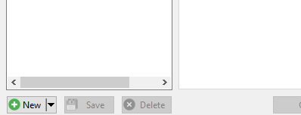

- Input login info (IP: localhost, Port: 3306, ID: root, Password: …)

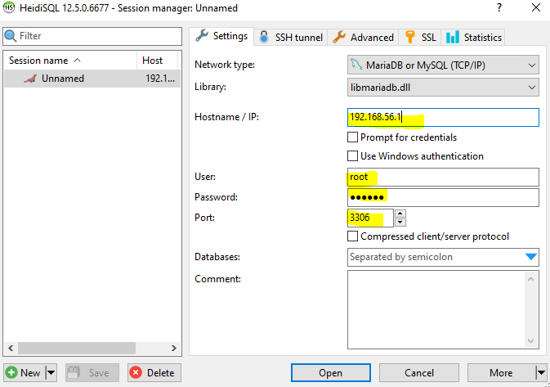

- Connect

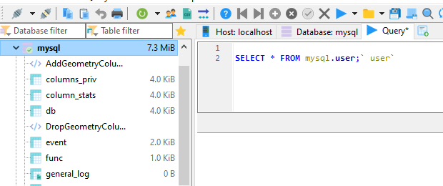

WIN!!